FORMAL CASE REPORT

Format (5 points)
- Typed
- 12 point font
- Headings. Remember, the easier you make it for me to find what I am looking for the easier it is to give you points for addressing the concepts
- Concise language. This is a “police report”. Relevant information only.
- 3rd person- Do not include I, we, he, she, they, etc.

Part 1: Forensic Anthropologist Report (Act 1.2.3)
Introduction: Provide a case description. Ex. Where was the body found, any evidence found at the scene, Etc. Make it up but relate it to your case. Refer back to the activity. (2 points)

Summary of Findings: Provide evidence and support for your findings for each trait - sex, ethnic origin, age and height. NOTE: You do not need to list every measurement/observation as evidence.
- Give 3 factors that support Race (3 points)
Example:________ measurement is a reliable indicator of race. The measurement of ____ (units) fell into the range of _____ to ____(units) suggesting the skeleton was of _______________ ethnic origin.

- Give 3 factors that support Gender (3 points)
The pelvis is the best evidence used to determine the gender of an unknown skeleton. The observation of __________ supports the sex of __________.

- Give 2 factors that support age (2 points)

- Give the measurements and the formulas used that helped determine estimated height range. (3 points)

- Discuss inconsistencies in the data and address the limitations of these methods in determining identity. (3 points) ______ was an inconsistent measurement found when determining ____. This measurement indicated ____, but ______________ other evidence supported the conclusion of ______. Why do we find inconsistencies??

Conclusion: (4 points)
Sum up the case findings from the forensic anthropologist and give your recommendations for the next steps of the investigation in 1-2 paragraphs. Use data and make suggestions for what the police should do next.

Part 2: DNA Analyst Report (from 1.3.1)

DNA Overview: Explain how the DNA sample was obtained (make it up). Explain the procedure that was conducted on the DNA sample to achieve the DNA fingerprint. Make sure to include a description of the restriction enzymes used. (3 points)

Gel Picture (2 points)
Include a picture of the gel with results visible.

Interpretation (10 points)
Use measurements and banding patterns to explain relationships between victims. Use lane numbers to be clear in your descriptions. You may add graphics or shapes to the gel pictures to explain. See example below. You must compare banding patterns for BOTH restriction enzymes for BOTH missing persons to get full credit. You CANNOT just say lane x and lane y match. You have to explain what is going on and how you can tell that they match (in terms of restriction enzymes and DNA. This needs to be detailed enough that someone with little DNA knowledge could understand.

Example gel interpretations:
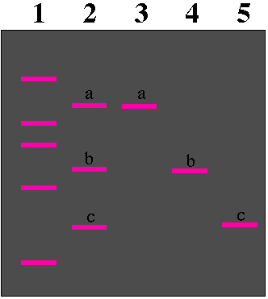

Bands “a” in lane 2 and 3 are at the same location suggesting _______.
Bands “ b” in lane 2 and 4 migrated the same distance of __ mm suggesting____.

Final Conclusion: (3 points)
Add details found in DNA evidence to your conclusion from Part 1. Use information from the entire case to sum up the identification experience. INCLUDE THE NAME OF THE MISSING PERSON and give details explaining how you know beyond a doubt that it was them.

